In DFD diagram we have different types of symbolic representation described below---

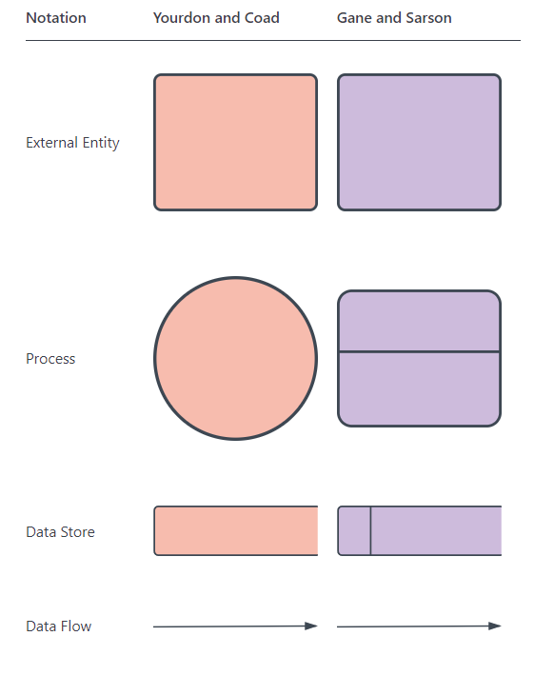

We can use any one of them …

Example of one Context level DFD ON health care management as we discussed –

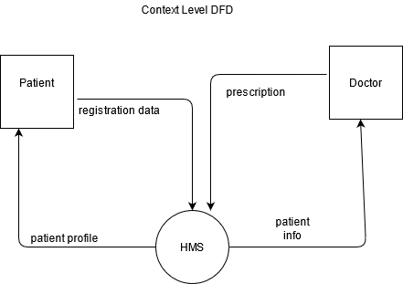

From the above description we understand below user story and process that can be simplified—

User story—patient Registration , Doctor’s service

Process---patient registration ;

Description: patient enters the data about himself and latter that must be saved based on various process validation and after that is done we can save them in database and in return patient must get a confirmation ID as token of confirmed admission.

Process—Doctor service;

Description: A doctor on taking any patient case can easily get the patient information online after putting the patient ID given to him by hospital staff.

**Level 1 DFD for patient registration**

